Foundation
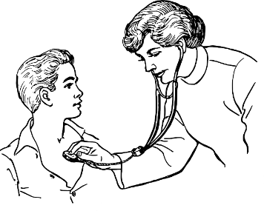

Doctor
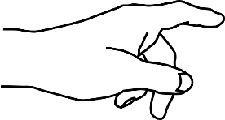
Bank
Point
CLB 1L

Doctor
Bank
Point

CLB 2L
Check one box.
☑

Shopping 
Banking 
Doctor’s appointment 

Foundation L

Point

CLB 1L

Check ✔ one 1

Groceries

Medication

CLB 2L
Check ✔ one 1

Buying medication
Grocery shopping

Taking the bus Going to the bank

CLB 3L+

Circle one

Shopping
Work

Friends Bus

CLB 3L+
Check ✔ two 2

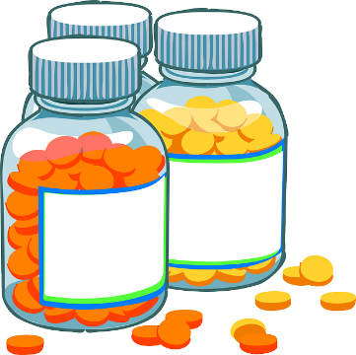

Buying medication
Grocery shopping

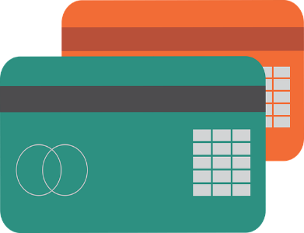
Using a bank card
Using the bus

Learning Strategies Needs Assessment
to be completed together with the instructor

Name: ________________ Date: __________

Manage Learning  *(Emerging stage of the Continuum) | Beginning | On my way | Success
Set learning goals
Bring learning materials to class
Work at home
Keep a learning portfolio
Ask for help
Use first language for learning

Ask your classmate.
Write in the table.

No. | What’s your first name?  How do you spell it? | What is your choice?

Instructor Observation

Learner:
Education:
Start Date:
Term:
Date | Observation  Needs/Strengths | Needs/Remedial Strategies | Progress

This is Dan.
Dan goes grocery shopping.
He can’t understand labels.
What can he do in class?

- learn about fruits and vegetables
- learn about prices
- learn about best before dates

My learning goal

Start date: __________________ End date: ____________________

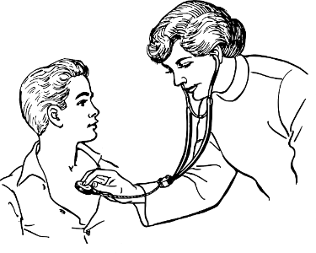
At the doctor’s office

 My name is…

 The date of my appointment.

 The date of my appointment.

 My first and last name on a form.

4 Language Skills

Write 1 skill you need to work on:

______________________________________________________________________________

My Learning Goals

Goal: __________________________________________________

Activities:
________________________________________________________________________________________________________________________________________________________________________________________________________________________________________

Check-in dates:
Date: _____________________ Signature: __________________
Date: _____________________ Signature: __________________
Date: _____________________ Signature: __________________
Date: _____________________ Signature: __________________

My Notes

How did you feel in class today?

Why?

Monday
Tuesday
Wednesday
Thursday
Friday

Name __________________ Date: _________________

My attendance for two weeks

Sun | Mon | Tues | Wed | Thurs | Fri | Sat
I came to school every day □
I practised 4 language skills □

 | _____________ |  | _____________
 | _____________ |  | _____________

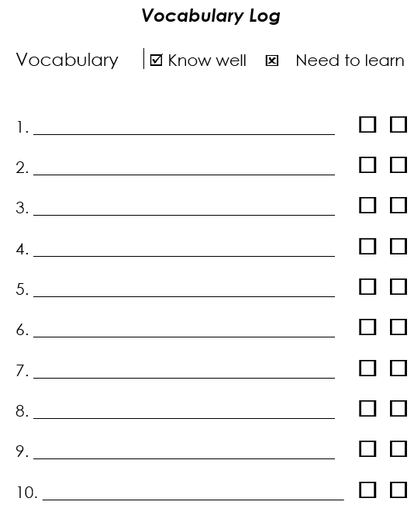

Name: _______________________________________ CLB:
Reading
Literacy Skills Development

Literacy Skills | Can do | Needs help | Date

CLB 2L
Copy the sentence on the lines below.
Name: ______________________________________
Date: _______________________________________

I have a headache.

___________________________________________________
___________________________________________________
___________________________________________________
___________________________________________________

CLB 2L
Write sentences with the words:

headache toothache stomachache
backache earache
I have a headache.

1. _____ _______ ____ ______________________.

2. _____ _______ ____ _____________________.

3. _____ _______ ____ _____________________.

4. _____ _______ ____ _____________________
CLB 2L

Read a note to the teacher.
Answer the questions.

November 19th, 2017

Dear Ms. Allison,

I have a headache today.
Thank you.

Febe

Questions:
1. What is the date? ______________________________________
2. What is the teacher’s name? _________________________
3. What’s wrong? _________________________________________
4. What is the student’s name? ____________________________

CLB 2L

Write:
- the date
- your teacher’s name
- the reason of your absence
- your name

___________________________

Dear Ms. ____________________,

I have a _________________________ today.

Thank you.

______________________

CLB 2L

Write an absence note to your teacher.

_________________________
Dear Ms. __________________________,

____ ________ _____ ___________ today.

Thank you.
_______________

_________________________

_______ ____ __________________________,

____ ________ _____ ___________ today.

Thank you.

______________________

